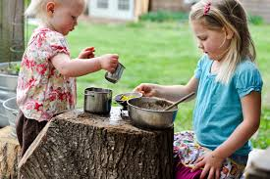  Contact us:  PHONE:  07907815270  WEBSITE  tinystepspre-school.com  EMAIL:  tinystepspreschool@outlook.com  Helen Heath – Manager  Connie Bryson – Manager |  | 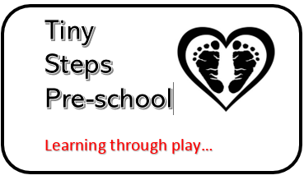  Tiny steps pre school  Learning through play  Exploring and discovery  At Tiny Steps pre-school we want children to thrive, to explore and allow their natural curiosity to develop their learning. Children will be encouraged supported and observed, these observations will form the basis of their next steps to learning. Planning will be child led and guided by staff’s observations and knowledge of the individual child guiding them towards their own discoveries.  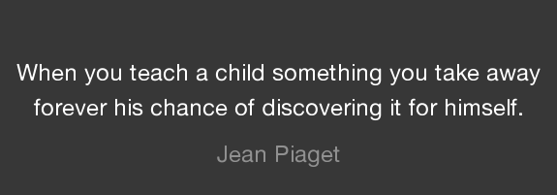  Fun  We want the children with us to have fun, to enjoy their learning which often they don’t even realise is happening.  Playing in the mud to make mud pies, children count out their measurements, compare quantities, engage in social play extending and developing their language.  Using pipes and jugs in the water play they manipulate materials explore how things change, assess and change their activity as needed. Use numbers and counting as they record amounts. Learning mark making skills as they do  In the home corner they copy social skills they see from their parents, often talk about things they do at home, extend their play by making shopping lists, writing letters or recording telephone numbers. They play with other children pretending to take on other roles.

