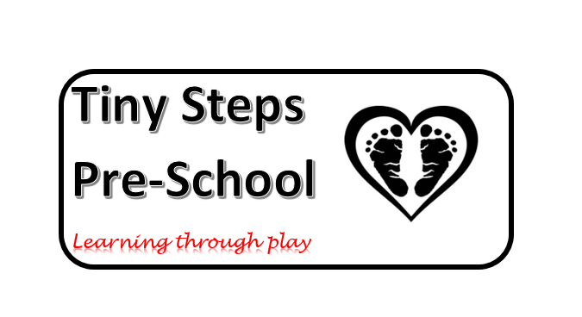
Tiny Steps Pre-School
Welcome Pack

f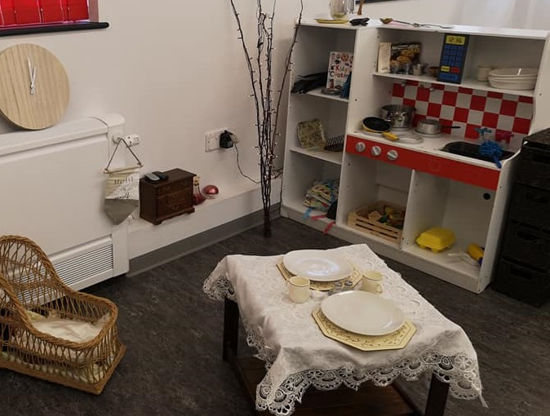
Welcome to Tiny Steps pre school, we hope the following information will act as a guide as to what goes on within our setting, showing what our priorities are and how we value working together with you to ensure we give your children a happy, healthy, safe and secure start to their education away from home.
At Tiny Steps we aim to:
▪▪ provide high quality care and education for children within our setting
▪▪ work in partnership with parents to ensure children are happy, so they can learn and develop to their full potential;
▪▪ add to the life and well-being of the local community; and
▪▪ offer children and their parents a service that promotes equality and values diversity.

Parents
We believe all parents have the right to be:
▪▪ valued and respected
▪▪ kept informed
▪▪ consulted
▪▪ involved and
▪▪ included at all levels
We aim to ensure that each child:
▪▪ is in a safe and stimulating environment;
▪▪ is given generous care and attention, because of our ratio of qualified staff to children.
▪▪ has the chance to join with other children and adults to play, work and learn together;
▪▪ is helped to move her/his learning forward and build on their existing interests and skills.
▪▪ has a personal key person who makes sure each child makes satisfying progress;
▪▪ is in a pre-school that sees parents as partners in helping each child to learn and develop;

Children's development and learning
The provision for children's development and learning is guided by Development Matters in The Early Years Foundation Stage(DfE 2012). Our provision reflects the four key themes and these are the principles of how we put them into practice.
A Unique Child
Every child is a unique child who is constantly learning and can be resilient, capable, confident and self-assured.

Positive Relationships
Children learn to be strong & independent through positive relationships

Enabling Environments
Children learn and develop well in enabling environments, in which their experiences respond to their individual needs & there is a strong partnership between practitioners, parents & carers

Learning and Development
Children develop & learn in different ways and at different rates. The framework covers the education & care of all children in early years provision, including children with special educational needs & disabilities.

How we provide for development and learning
Children start to learn about the world around them from the moment they are born. The care and education offered at Tiny Steps helps children to continue to do this by providing all of the children with interesting activities that are appropriate for their age and stage of development.

The Areas of Development and Learning comprise:
Prime Areas
▪▪ Personal, social and emotional development;
▪▪ Physical Development
▪▪ Communication & Language
Specific Areas
▪▪ Literacy
▪▪ Mathematics
▪▪ Understanding the World
▪▪ Expressive Arts & Design

For each area, the level of progress that children are expected to have attained by the end of the Early Years Foundation Stage is defined by the Early Learning Goals. These goals state what it is expected that children will know and be able to do by the end of the reception year of their education.

The ‘Development Matters’ also sets out the likely stages of progress a child makes along their learning journey towards the early learning goals. Our pre school supports children to develop the knowledge, skills and understanding for:

Our approach to learning and development and assessment

Learning through play
Play helps young children to learn and develop through doing and talking, which research has shown to be the means by which young children learn to think. At pre-school we use Development Matters in the Early Years Foundation Stage (EYFS) to plan and provide a range of play activities which help children to make progress in each of the areas of learning and development. In some of these activities children decide how they will use the activity and, in others, an adult takes the lead in helping the children to take part in the activity. In all activities information from the Development Matters in the Early Years Foundation Stage have been used to decide what equipment to provide and how to provide it.

Characteristics of effective learning
We understand that all children engage with other people and their environment through the characteristics of effective learning that are described in the Development Matters the Early Years Foundation Stage guidance as:
▪▪ Playing and exploring – engagement;
▪▪ Active learning – motivation; and
▪▪ Creating and thinking critically – thinking

We aim to provide for the characteristics of effective learning by observing how a child is learning and being clear about what we can do and provide in order to support each child to remain an effective and motivated learner.

Assessment
We assess how young children are learning and developing by observing them frequently. We use information that we gain from observations, as well as from photographs or videos of the children, to document their progress on Tapestry which is an online secure application developed for pre-schools and schools, this helps us to track their progress and see where this may be leading them. We believe that parents know their children best and we ask them to contribute to assessment by sharing information about what their children like to do at home and how they as parents are supporting development.

We make periodic assessment summaries of children’s achievement based on our ongoing development records. These form part of children’s records of achievement. We undertake these assessment summaries at regular intervals as well as times of transition, such as when a child goes on to school.

The progress check at age two
The Early Years Foundation Stage requires that we supply parents and carers with a short written summary of their child’s development in the three prime areas of learning and development: personal, social and emotional development; physical development; and communication and language; when a child is aged between 24-36 months. The key person is responsible for completing the check using information from ongoing observational assessments carried out as part of our everyday practice, taking account of the views and contributions of parents and other professionals.

Working together for your children

In our pre-school we maintain the ratio of adults to children which is set through the Safeguarding and Welfare Requirements. This helps us to:
▪▪ give time and attention to each child;
▪▪ talk with the children about their interests and activities;
▪▪ help children to experience and benefit from the activities and resources available; and
▪▪ allow the children to explore and be adventurous in safety.

Tiny Steps pre school Staff

Manager
Helen Heath Foundation Degree in
Childhood studies
NNEB 1st Aider

Manager
Connie Bryson Level 3 diploma 1st Aider

Pre school Assistant

Chelsea Corr Level 2 diploma 1st Aider

All staff regularly update their training which includes Food Hygiene, Child Protection & First Aid, amongst others such as Behaviour Management.

How parents take part in the setting

At Tiny Steps we recognise parents as the first and most important educators of their children. All of the staff see themselves as partners with parents in providing care and education for their children.
▪▪ exchanging knowledge about their children's needs, activities, interests and progress with the staff;
▪▪ contributing to the progress check at age two;
▪▪ building friendships with other parents in the setting at various functions organised by the setting.
.

Key persons and your child

At Tiny Steps we use a key person approach. This means that each member of staff has a group of children for whom she/he is particularly responsible. Your child's key person will be the person who works with you to make sure that what we provide is right for your child's particular needs and interests. When your child first starts at the Tiny steps, she/he will help your child to settle and throughout your child's time here, she/he will help your child to benefit from the setting's activities.

Our timetable and routines

We believe that care and education are equally important in the experience which we offer children.
The routines and activities that make up the day in the setting are provided in ways that:
▪▪ help each child to feel that she/he is a valued member of the setting;
▪▪ ensure the safety of each child;
▪▪ help children to gain from the social experience of being part of a group; and
▪▪ provide children with opportunities to learn and help them to value learning.

We organise our sessions so that the children can choose from, and work at, a range of activities and, in doing so, build up their ability to select and work through a task to its completion. The children are also helped and encouraged to take part in adult-led small and large group activities which introduce them to new experiences and help them to gain new skills, as well as helping them to learn to work with others.
Outdoor activities contribute to children's health, their physical development and their knowledge of the world around them. The children have the opportunity, and are encouraged, to take part in outdoor child-chosen and adult-led activities.

We organise the day so that children can take part in a variety of child-chosen and adult-led activities. These take account of children's changing energy levels throughout the day. The setting caters for children's individual needs for rest and quiet activities during the day.

We are open daily – Monday to Friday 9am – 3.15pm Term time only. Please refer to our policies for admission and waiting list policies.

Snacks and meals
We make snack a social time at which children eat together. We plan the menus for snack so that they provide the children with healthy and nutritious food. Do tell us about your child's dietary needs and we will make sure that these are met.

Policies
Copies of our policies and procedures are available for you to see in the Pre school Office or on the website. www.tinystepspre-school.com
Our policies help us to make sure that the service provided by us is a high quality one and that being a member of our pre school is an enjoyable and beneficial experience for each child and her/his parents.

Contents of Policies and Procedures for the EYFS

1. Safeguarding and promoting children’s welfare
Safeguarding Children
Safeguarding children and child protection
Confidentiality and access to records
Information sharing
Uncollected children
Missing child
Supervision of children on outings and visits
Making a complaint
Safeguarding children & protecting them from inappropriate use of cameras, mobile phone, video cameras etc

Equality of opportunity
Valuing diversity and promoting equality
Supporting children with special educational needs
Achieving positive behaviour

Promoting health and hygiene
Administering medicines
Managing children with allergies, or who are sick or infectious
Nappy changing
No-smoking
Food and drink
First Aid
Sun protection

- Suitable People Employment
Employment and staffing
Induction of staff, volunteers and managers Student placements

- Suitable premises, environment and equipment
Health and safety
Risk assessment
Health and safety general standards
Health and safety risk assessment template(shown as 3.5)
Fire safety and emergency evacuation
Fire safety risk assessment template
Reporting and recording of accidents and incidents

- Organisation
Administration
Admissions
Application to join
Registration form

Chid care practice
The role of the key person in the setting and settling-in
Early year’s prospectus

Documentation
Children’s records

.

Fees

Our fees are payable monthly in advance, but must be paid if children are absent without notice for a short period of time.
For your child to keep her/his place at Tiny Steps, you must pay the fees, failure to pay will result in your child’s place being suspended. We are in receipt of Nursery Education Funding for two, three and four year olds; where funding is not received, then fees apply. Late collections from pre-school will be charged an additional fee.

Starting at Tiny Steps

The first days
We want your child to feel happy and safe with us. To make sure that this is the case, the staff will work with you to decide on how to help your child to settle into the setting. We have a policy about helping children to settle into our setting, which is available from the pre-school Office.

Clothing
We provide protective clothing for the children when they play with messy activities. We encourage children to gain the skills that help them to be independent and look after themselves. These include taking themselves to the toilet and taking off, and putting on, outdoor clothes. Clothing and shoes that are easy for them to manage will help them to do this.
Outdoor Play – we suggest that all children bring wellingtons in during wet weather and if possible waterproof clothing, so that we can go out what ever the weather! During warm weather we strongly advise parents to bring appropriate clothing, and to provide them with hats and sun cream to protect them from the sun’s harmful rays and heat.

Parking
Please ensure you drive slowly when entering and leaving the pre-school, also be especially vigilant for children getting into/out of cars and when crossing the children’s walkway. Please be respectful to local residents at all times.

Snack Time
At mid-morning break the children are given fruit or a healthy snack and a drink of milk or water.
Birthday cakes can be brought in to celebrate children’s birthdays. HOWEVER, PLEASE ENSURE THE CAKE CONTAINS NO TRACES OF NUTS.

Lunchtime
Children must bring their own lunch, pleasure ensure this is NUT FREE. We encourage you to provide a healthy balance and would like these to be chocolate bar and sweet free.

Absence from School
Please inform pre-school as soon as possible if your child is ill and will not be attending.

Notice of Leaving Nursery
Please inform management in writing two months prior to leaving date.

Security
Please pay attention to the notices and close all doors behind you, only staff can let people in to the setting.

General Health
All children with a temperature, diarrhoea or sickness should be kept at home, both for their own comfort, and to prevent the spread of infection. It is important that you read through the chart on Communicable Diseases and follow the recommendations. From time to time there are outbreaks of head lice, please check your child’s hair regularly and inform a member of staff if head lice are found. Notices regarding any health problems within pre school will be clearly displayed to parents or letters will be sent home in the case of a pandemic.

Medication
We have to be careful when administering medicines to children on your behalf. To protect our staff and your children, we will only give medicines if a parental consent form has been completed and the medication is prescribed or to help prevent febrile convulsions.

Accidents.
All pre school Staff are qualified first aiders. If a child has an accident whilst at pre school a member of staff will complete an accident form and you may be required to sign it.

We strive to give the children clear boundaries and reinforce good behaviour with verbal praise and smiley faces. Unacceptable behaviour will be dealt with on a daily basis, encouraging children to know right from wrong. If we feel that a child is not responding, parents will be informed, so that we can work together to encourage positive behaviour.

Special Educational Needs and Disabilities
The setting welcomes all children provided we are confident that we can offer them the quality care they require. The child’s developmental age is taken into account in order that we can assess the staffing ratios they require. Staff would always work with parents and other agencies if necessary to provide a secure environment catering for developing individual needs.

Equal Opportunities
All children will be given the opportunity to develop to their full potential and with a positive identity, regardless of colour, culture, gender or disability.

Complaints Procedure
If you are unhappy about any aspect of the EYFS, complaints must be taken to either of the pre school managers.

Registration details
Ofsted - Telephone 0300 123 1231

Information Sharing Guide

We welcome parents to have access to their children’s records, in the following ways:

- Tapestry – please feel free to add any comments you may have on the comments section
- Other records such as Initial Records of Concern, IEP s etc – may be viewed by arrangement as they may contain reference to other named children
- Child Protection related records – will be dealt with in accordance to our Child Protection Policy

Queries relating to any of the above points, please contact either of the pre-school managers.

Things to bring to Nursery on first and subsequent days

- Nappies (if applicable).
- One set of spare clothes.
- Wellington Boots, waterproofs.
- Coat, Hat and gloves (either sun/woolly dependent on weather).
- Sun cream.
- Child profile and registration forms completed
- Birth certificate and red book (for authentication)
N.B. Please name all clothing and personal items to avoid confusion.

Things to check at Nursery

- Your child’s draw.
- Notice boards for new information and events posters.
- Dirty/wet spare clothes in bag.
- Lost Property regularly.

Any queries please do not hesitate to speak to a member of staff.

